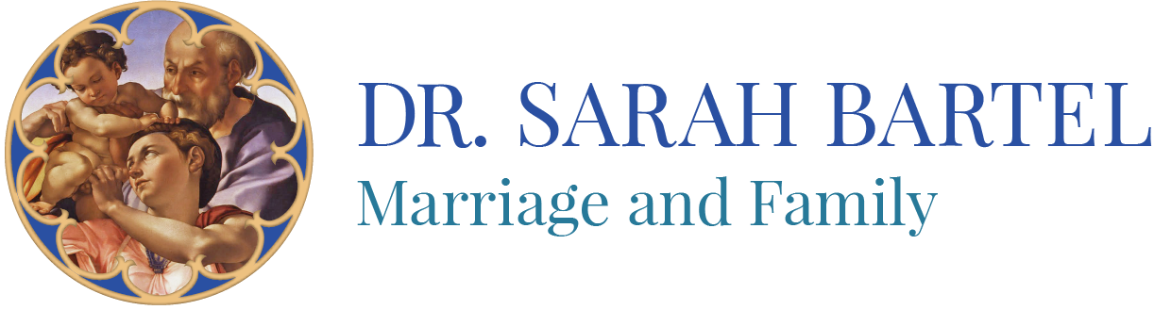
Introduction to Morality
Online Course
2017-2018

Dr. Sarah Bartel
www.drsarahbartel.com

Dates of Live Teaching:
Sat, Aug. 19 4-5:30 pm, 7-9 pm
Sun, Sept 10 8:45-9:45 am
Sun, Oct. 22 8:45-9:45 am
Sun, Feb. 11 9:45-10:45 am
Sun., Apr. 15 8:45-9:45 am

Recordings will be done within the week following live teaching.
Course Description
This course will introduce the fundamental question of moral theology and topics that include theological anthropology, freedom for excellence and freedom of indifference, the parts of a human act, natural law, sin and virtue, conscience, the four cardinal virtues and the three theological virtues, and the Ten Commandments. It will compare moral relativism with objective moral truth, reflecting on Scripture, reason, and the Catholic moral tradition as sources for determining moral action in the context of following Christ.
Texts
Catechism of the Catholic Church
Servais Pinckaers, Morality: The Catholic View. South Bend, Indiana: The Augustine Press, 2001.
Steven J. Jensen, Living the Good Life: A Beginner’s Thomistic Ethics. Washington, D.C.: The Catholic University of America Press, 2013.

Course Outline

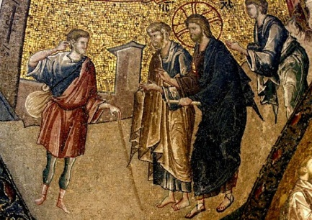  Mosaic, Christ and the Rich Young Man | Saturday, August 19, 4-5:30 pm  The Central Question of Morality  - Reflection on Mt 19:16-30  What is the central question of morality?  - Who is man? What is theological anthropology?  - What is our telos? How does it relate to beatitude? | 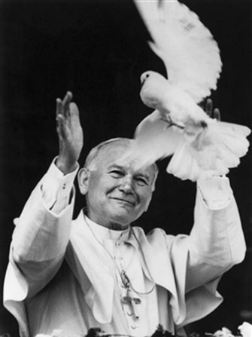
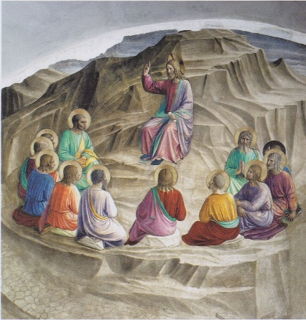  Sermon on the Mount, Fra Angelico | Saturday, August 19, 7-9 pm  The Beatitudes and Freedom  - Reflection on the Beatitudes  - Scripture and the Sources of morality  - Freedom from and freedom for | Homework:  Begin reading Living the Good Life. Finish by January.  Read Morality: A Catholic View pp. 65-81  Read Catechism of the Catholic Church 1691-1748  Write a paragraph describing a difficult moral question. Leave it unresolved.
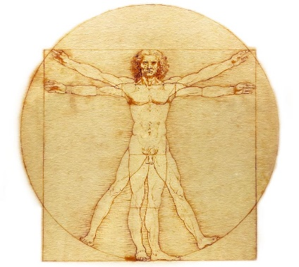  Vitruvian Man, Leonardo Da Vinci | Sun, Sept 10 8:45-9:45 am  Natural Law and The Parts of a Human Act  Quiz on readings and lectures  - Natural Law  - Parts of a Human Act  - Object  - End (Intention)  - Circumstances | Homework:  Read Catechism  1749-1756  1776-1802  1846-1876  Morality: The Catholic View  pp. 96-111
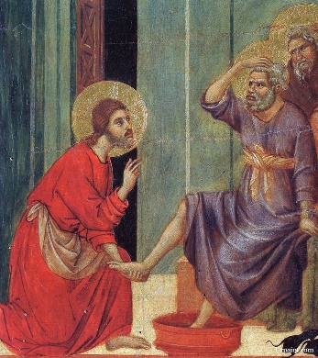  Christ Washes the Disciple’s Feet, Giotto | Sun, Oct. 22 8:45-9:45 am  Sin and Grace  Quiz on readings and lectures  - Conscience  - Sin and Grace  - Discipleship, Ongoing Conversion, Growth in holiness  - Process of Moral Decision-Making | Homework:  Read Catechism  1803-1845  1965-2016  2087-2094  Morality:The Catholic View pp. 82-95  Read Oscar Wilde, The Young King.
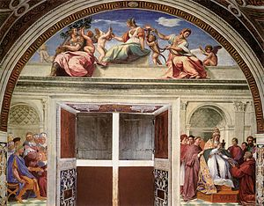  Cardinal and Theological Virtues, Raphael | Sun., Jan 28 8:45-9:45 am  Virtue  Quiz on readings and lectures  - Virtue: Theological Virtues  - Virtue: Cardinal Virtues | Homework:  Read Catechism  pp. 496-497  2052-2557
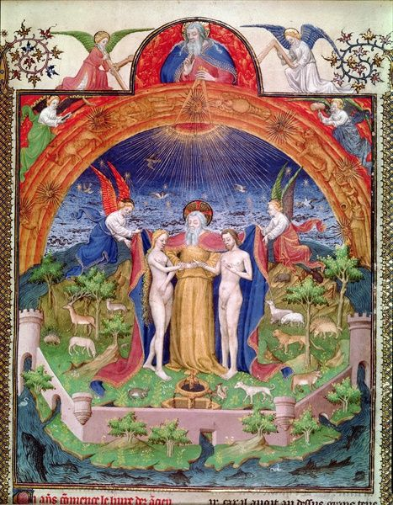  Creation of Adam and Eve, Jean Fouquet | Sun., Apr. 15 8:45-9:45 am  The Ten Commandments and Special Topics  Quiz on readings and lectures  - Ten Commandments  - Life Issues, Bioethics, Catholic Social Teaching, Just War  - Church Documents | Go set the world on fire!  